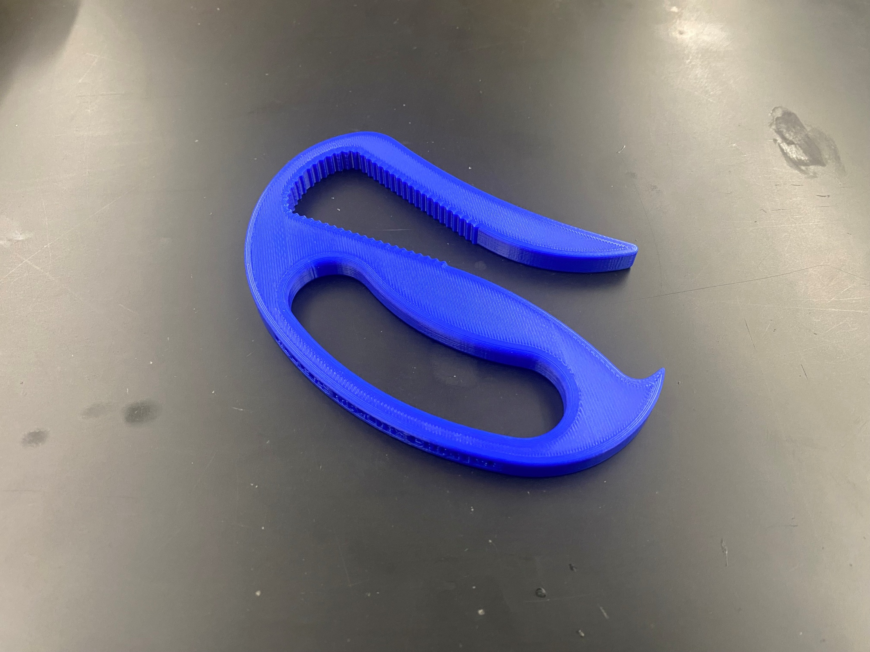

Assistive Bottle Opener

**3D Printing, Soldering, and Assembly Directions**

Author: Amber Cruz

Model Creator: MakersMakingChange (Thingiverse)

Assistive Bottle Opener

**3D Printing Instructions**

1. Download the device file from the virtual library.
2. Open PrusaSlicer and click the “Add…” button (see Figure 1), then select the device file from the downloads folder.

Figure 1. Button to Import Files into PrusaSlicer.

1. Go to the “Print Settings” tab in the top left corner of PrusaSlicer and change the number of perimeters to 4 (see red arrow in Figure 2). Then double-click on the “Infill” subtab (see blue arrow in Figure 2).

Figure 2. Adjusted Perimeter Settings.

1. Change the fill density to 50% and the fill pattern to Gyroid (see red box in Figure 3).

Figure 3. Adjusted Infill Settings.

1. Go back to the “Plater” tab in the top left corner of PrusaSlicer. Then click the “Print settings” drop-down menu and select the 0.20mm Structural option (see red arrow in Figure 4).
   1. *Note:* The titles of each print setting option will vary slightly between printer models, so there may not be an option matching this wording exactly – that’s ok! What’s important is that you select one of the 0.20mm options.

Figure 4. Main Plate Settings.

1. Open the Filament drop-down menu (see blue arrow in Figure 4) and select the filament type you want to print in.
   1. *Note:* The recommended material for this device is PLA, but PETG is also acceptable.
2. Open the Printer drop-down menu (see green arrow in Figure 4) and select your printer make and model.
   1. *Note:* If you don’t see your specific printer in the drop-down menu, follow these instructions to add them: <https://help.prusa3d.com/article/configuration-wizard_1754>
3. Click the “Slice now” button in the bottom right corner of PrusaSlicer and wait for the software to finish slicing the file.
4. Once the slicing is finished, click “Export G-code” (see Figure 5) and save the G-code to a flash drive.

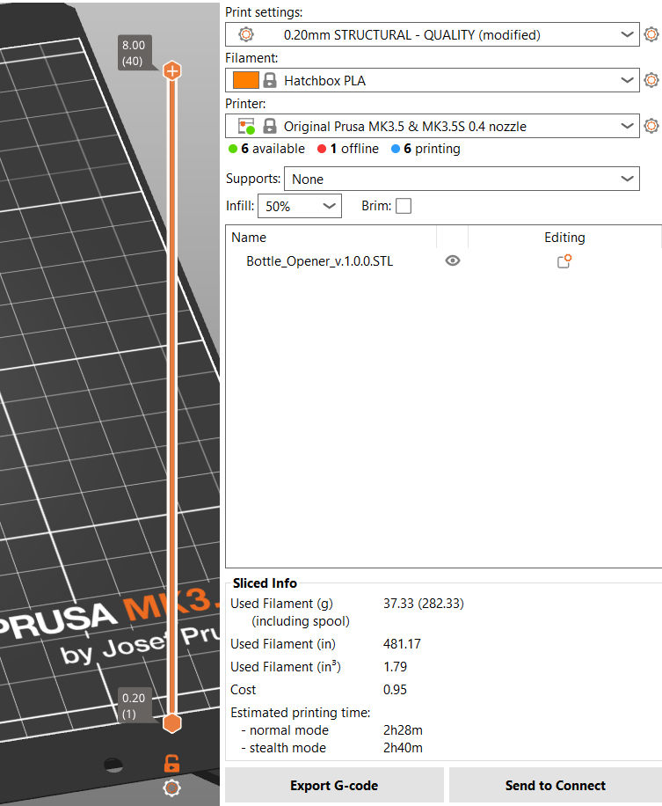

Figure 5. Export G-code Button.

1. Insert the flash drive into your 3D printer, select the G-code and print!

Assistive Bottle Opener

**Soldering Instructions**

1. No soldering is required for this device.

Assistive Bottle Opener

**Assembly Instructions**

1. No assembly is required for this device.